|  |  |
| --- | --- |
| REVIEW 2 | **FPT ACADEMY INTERNATIONAL**  **FPT – APTECH COMPUTER EDUCATION** |

**Centre Name: ACE-HCMC-2-FPT.**

**Address: 590 Cach Mang Thang 8, District 3, Ho Chi Minh City, Viet Nam.**

**Excellent Coaching**

|  |  |  |
| --- | --- | --- |
| **Supervisor:** | PHAM THI LANH | |
| **Term:** | 1 | |
| **Batch No:** | T1.2103.M0 | |
| **Group No:** | 1 | |
| **Order:** | **Full name** | **Roll No.** |
| 1. | LE KHUONG DUY | Student1312097 |
| 2. | QUACH VU GIA BAO | Student1308991 |
| 3. | TRAN MANH PHAT | Student1312076 |
| 4. | PHAM HOANG GIA KIET | Student1312080 |

Month 6 Year 2021



This is to certify that

Mr: Le Khuong Duy

Mr: Quach Vu Gia Bao

Mr: Tran Manh Phat

Mr: Pham Hoang Gia Kiet

Has successfully Designed & Developed

**Excellent Coaching**

Submitted by:

Pham Thi Lanh

Date of issue:

Authorized Signature:

**CONTENTS**

# **ACKNOWLEDGEMENT**

I would like to acknowledge all those who have given moral support and helped in making the project a success.

I wish to express my gratitude to the e-Projects Team at the Head Office, who guided and helped me. I would also like to express my gratitude to all the staff members of my center for not only providing me with the opportunity to work with them on this project, but also for their support and encouragement throughout the process.

I also express my sincere gratitude to the e-Projects Team at the Aptech Head Office and my project guide at the organization, for her valuable guidance and support for the completion of this project.

And finally, I would like to offer many thanks to all my colleagues for their valuable suggestions and constructive feedback.

# **SYNOPSIS**

Excellent Coaching is into business for more than a decade. They have been advertising about their coaching classes through newspapers, pamphlets, television. Now with changing times, they have decided to go online as most of the students today are frequent users of Internet.

The website is to be developed for the Windows Platform using HTML5, JavaScript and Geolocation. The site should work well in all leading browsers including Chrome, IE, Firefox.

# **REVIEW 1**

# **REQUIREMENT SPECIFICATION**

The Web site is to be created based on the following requirements.

1. The Home Page should have suitable logo, and decent colour combination.
2. Information should be neatly placed at suitable location.
3. Various pages having information about different courses/subjects taught at the classes, Faculty/Teachers complete information and previous year’s success stories should be listed.
4. The site should display a menu which will contain the options for brief introduction about the above mentioned information, location/address of the coaching classes and any other information if required.
5. The information should be categorized according to different subjects like if a User wants to see details of ‘Commerce’ then he click on a Link/button/menu etc and he will see details of course structure of commerce. Similarly for ‘Mathematic’, ‘Languages’ and other subjects.
6. When a user selects any course stream, complete list of subjects for that course stream will be displayed.
7. Details of the courses should be displayed on the Web Page along with the title and it should be stored in Individual Word documents which can be downloaded or viewed by the User who wishes to see the same.
8. Price List for all courses should be available for download.
9. There should be a “Contact Us” page which will have the Address of the Coaching Classes and the mail address which when clicked will invoke the local mail client from where they can send an email. Address of the Company should be displayed using GeoLocation API (eg. GoogleMaps).

# **PROBLEM DEFINITION**

After reading the project specifications, the developer states the scope of the project very briefly. This is referred to as the problem definition. Queries of various staff members can be one or all of the following:

* 1. How many courses can be displayed on Homepage at a time?
  2. What information should be displayed about each courses in Homepage?
  3. Will users be able to contact the center when they have any questions?
  4. Will the users be able to feedback their opinions?
  5. Will the users be able to question about center’s services?

After consulting several IT companies and considering the budget constraints, the management of Cencer Excellent Coaching to launch the Web application as a single page responsive Web application using HTML5, CSS3, JavaScript, Geolocation API, Web Storage, AngularJS, and Bootstrap3.3 from getbootstrap.com, jQuery plugins, and Coffee Cup, Notepad++, or other HTML editor. Also, the site will be tested on popular browsers and mobile emulator software.

# **CUSTOMERS REQUIREMENT**

# **SPECIFICATIONS (CRS)**

##### **Client: Excellent Coaching Center**

##### **Business/Project Objectives:**

* + Provide a website to displays the programs and services about center such as: “About us”, “Opening Schedule”, “Services”, “News”, “Contact Us”, “Feedback”…
  + Enable customers to see what courses that they would like. Easier interactive with us.

##### **Inputs provided by clients:\4**

Inputs to the existing system.

Outputs from the existing system.

Process involved in the application.

Expected delivery dates.

List of deliverables.

##### **Hardware Requirement:**

* A minimum computer system that will help you access all the tools in the courses is a Pentium 166 or better
* 64 Megabytes of RAM or better

##### **Software Requirements:**

* Notepad/HTML editor
* Visual Studio Code

# **ARCHITECTURE & DESIGN OF THE SYSTEM**



Font End technologies

(HTML5, CSS3, Bootstrap, jQuery)



# **SITEMAP**

Contact Information

PaymentGuide

News 1

News 2

News 3

News 4

Service 1

Service 2

Service 3

Service 4

Program 1

Program 2

Program 3

Program 4

Courses 1

Courses 2

Courses 3

Courses 4

Opening Schedule

Education program

News

Services

PaymentGuide

Contact

Account

Home

Header

# **WEBSITE LAYOUTS**

Here are our layouts which will show you how we brainstormed ideas for the hospital’s web pages. Because of being academic website, we tried to build them SIMPLE but USEFUL and INFORMATIVE as much as possible.

The website is going to have several pages which include different information in the same main layout.

1. **Homepage**

* This layout below describes how we created our Homepage which contain three important parts:
* *Page-header and Navigation bar:*
* Page-header: must have Center Excellent Coaching’s logo, and other links is account, logout.
* Navigation bar is one of the most crucial sections in the whole website which will indicate people how they interact with us. It provide some information like Homepage, Opening Schedule, Education program, Services, News, Contact, Payment Guide. Each section must have brief information.
* *Content:*
* This part is customized belong to the title of the individual websites, especially Homepage with some descriptions about the Center of Excellent Coaching and introduces some information of teachers, and feedback, certification from students to create credibility.
* *Footer:*
* The final part off all our websites definitely Footer which will reveal some convenient ways to contact the center in different social channels like Email, Facebook, …

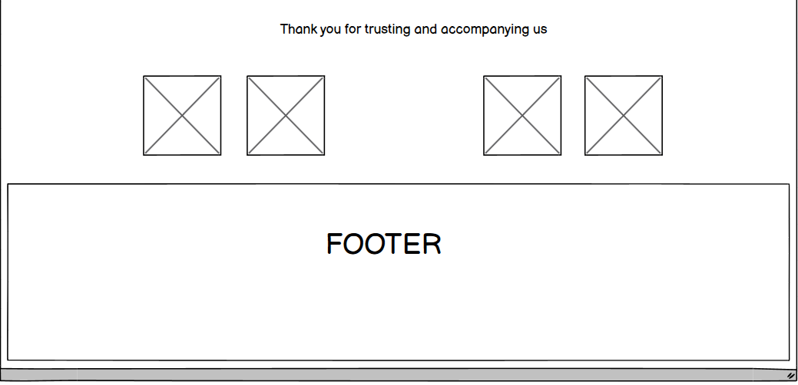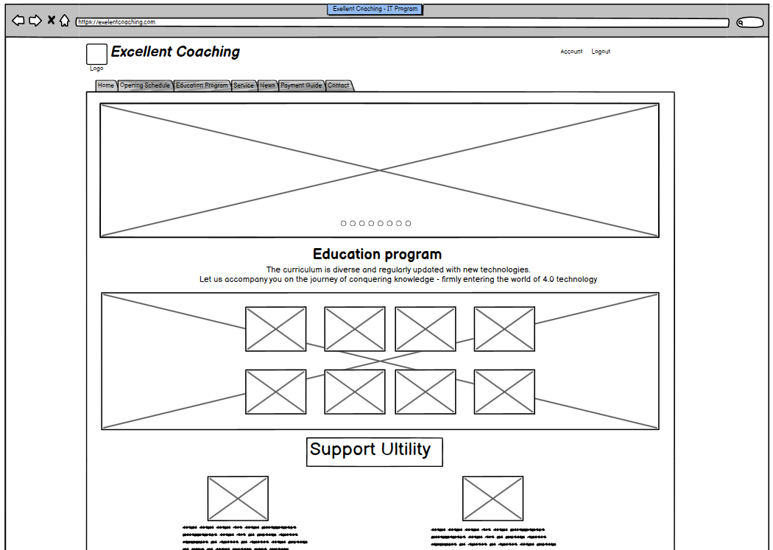

1. **Informative pages:**

This layout we will apply for most other pages (Opening Schedule, Education Program, Services, News, …) which provide different information about the center Excellent Coaching. It also has the same Page-header, Navigation bar and Footer as Homepage. But the main content will be changed.

Contact

Payment

News 1

News 2

News 3

Program 1

Program 2

Program 3

Service 1

Service 2

Service 3

Courses 1

Courses 2

Courses 3

Content

Footer

Contact

Payment Guide

News

Services

Program

Schedule

Home

Account

Logout

**Logo Excellent Coaching**

# **TASK SHEET 1**

|  |  |  |  |  |  |  |
| --- | --- | --- | --- | --- | --- | --- |
| **Project Ref. No.** | **Project Title** | **Activity Plan Prepared**  **by** | **Date of Preparation of Activity Plan** | | | |
| **Task** | **Actual Start Date** | **Actual Days** | **Teammate Names** | **Status** |
| Tab: Homepage, Opening Schedule | Excellent Coaching | Duy | 14/06/2021 | 7 | Duy | completed |
| Design logo, color scheme layout, background Tab: Education | Excellent Coaching | Bao | 14/06/2021 | 7 | Bao | completed |
| Tab: Payment guide. Contact | Excellent Coaching | Phat | 14/06/2021 | 7 | Phat | completed |
| Tab: Service, News | Excellent Coaching | Kiet | 14/06/2021 | 7 | Kiet | completed |

|  |  |
| --- | --- |
| Signature of Faculty | Signature of Leader Team |
|  |  |

# **REVIEW 2**

# **WEBSITE INTERFACE**

## Homepage

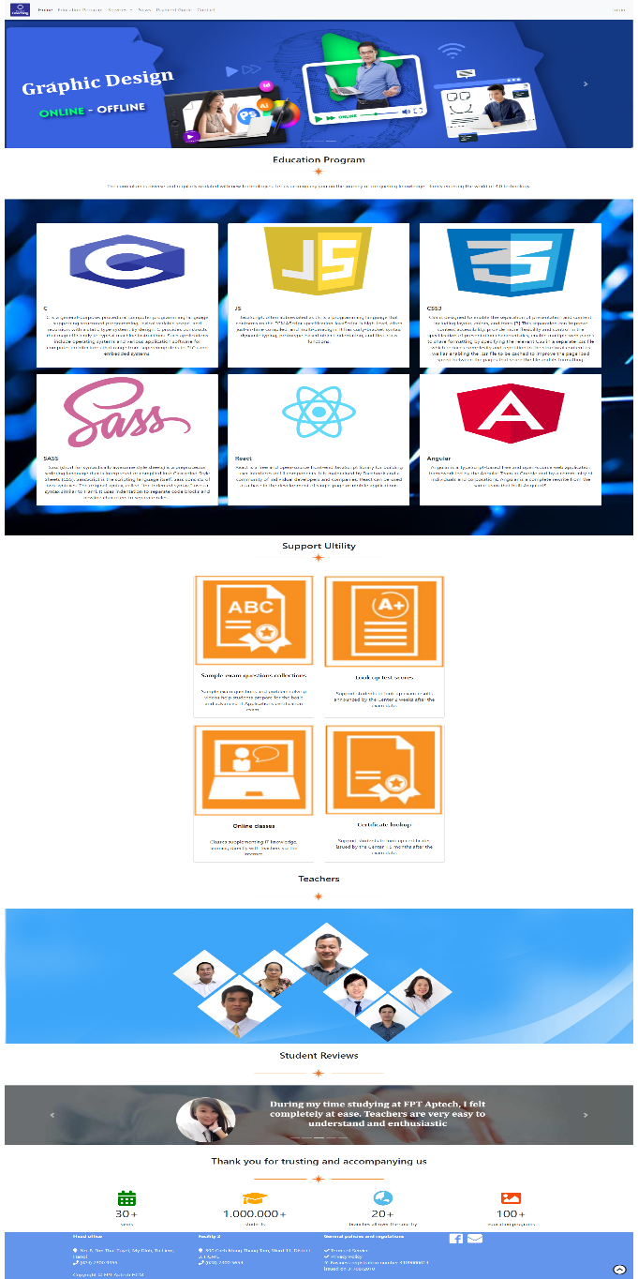

The homepage contains an overview of the excellent coaching center, examples of course programs, teacher information, students' opinions, the center's address as you see above picture.

|  |  |
| --- | --- |
| **Title** | **Description** |
| Home | * Exellent Coaching center’s address, main contacts * Display overview information where people can refer |
| Education program | * Display all course which people can have a best choice * About the details of the course, the course schedule, and the teachers directly teaching, cost of course * Register form where people can leave information and purchase the course |
| Services | * Display information about Software Development and Provide Software Equipment services. * The center provides software support services and provides equipment for other teaching center partners. * Display some of the centers partner that have cooperated. |
| News | * Display all information of exellent coaching center news * Information about new courses opening, new events are available |
| Payment Guide | * Display payment methods: directly and by banking transfer * Display address of center, working time of center |
| Contact | * Display braches of center exellent coaching, telephone, email to convenient for contact * Display google map where the center location * Display form “Contact Us” to leave people’s information and courses which they care about. |
| Login | * Display sign in form: people can login if already a member * Display sign up form: people can sign up to be a member of center * Display form retrieve password if member forget the password |

## Education Program

When you click to Education Program in the Homepage, this page below will show all of information about course is available.

When you choose any course, the details of that course will be displayed, including: general introduction of the subject, course route, direct teachers

You can purchase the course after fill all information and click button “Buy Now”, the page will show an alert to notice that make sure to buy that course.

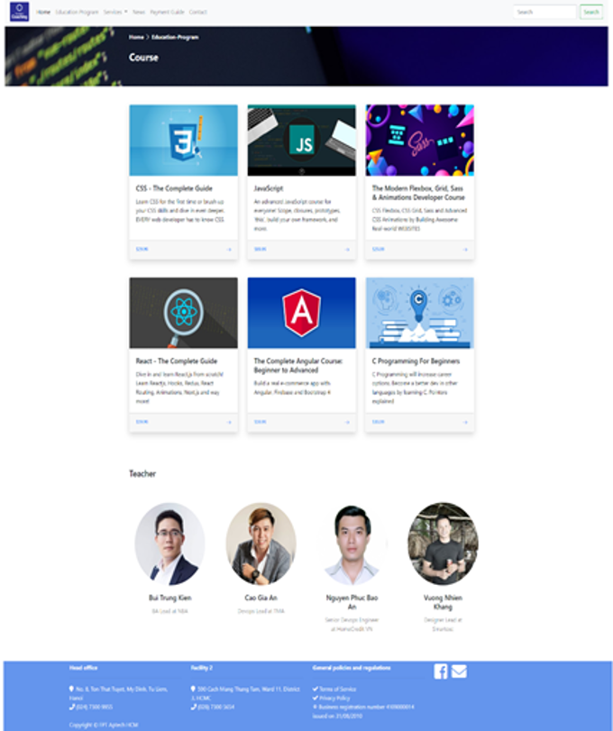

## Services

When you click Services on navigation bar, the page below will show up.

This page show detail information of services which center provide to another partners.

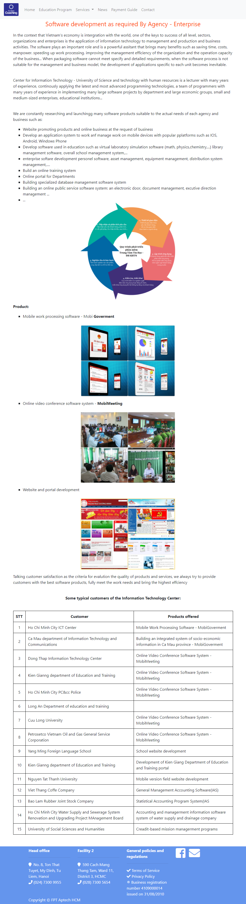

## News

When you click News, the page below will show up.

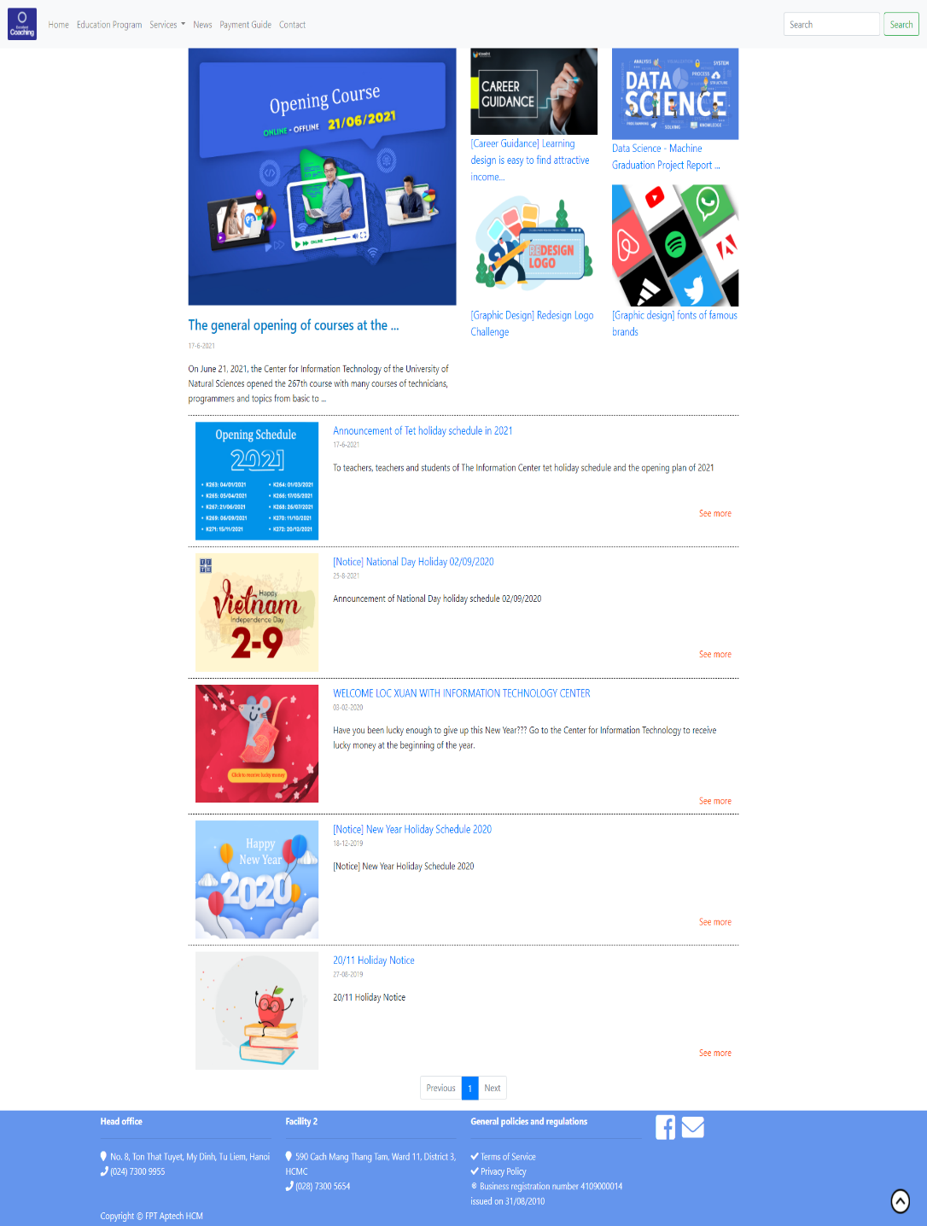This page show all of news available of center. You could see more information of news if you click ones. This page will link to another page and show all of details of that news you clicked.

## Payment Method

You will see two payment method: direct payment and bank transfer. When the pointer on the method, that method will be turn green, and when you click to choose any method, the content of that method will show up,

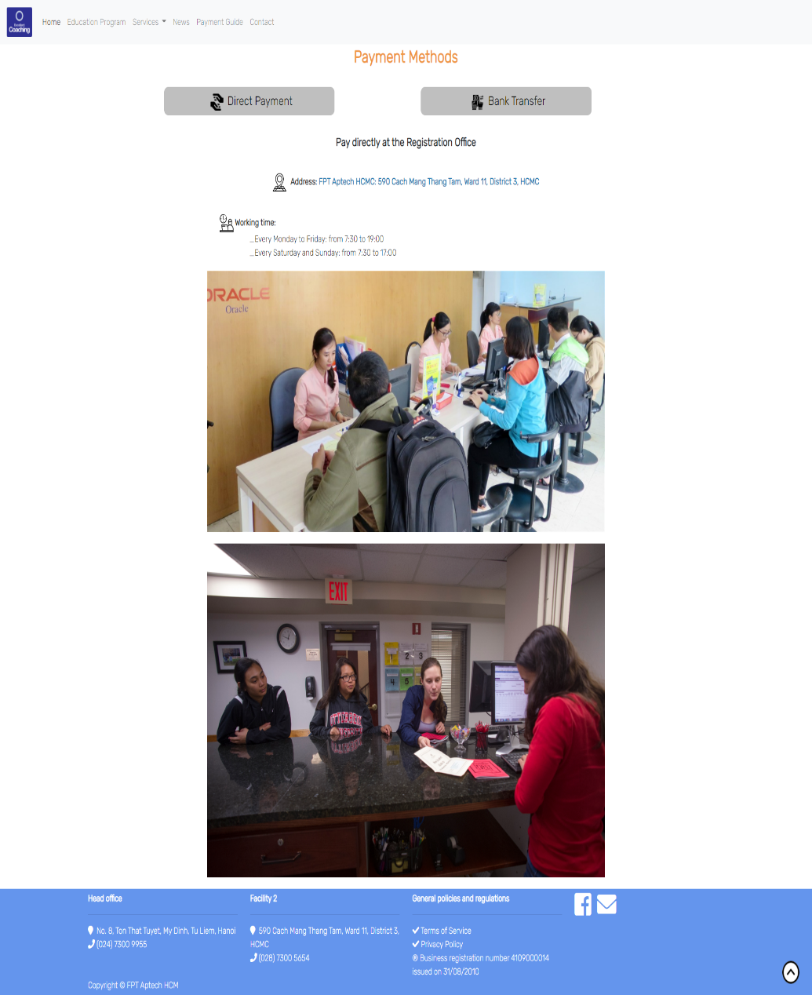

## Contact

When you click to Contact, this page will show the contact information of center with two branches, and map to the exellent coaching with Geolocation API.

The contact us form, will let you leave your information, when click submit button will show alert that confirm your information was sent.

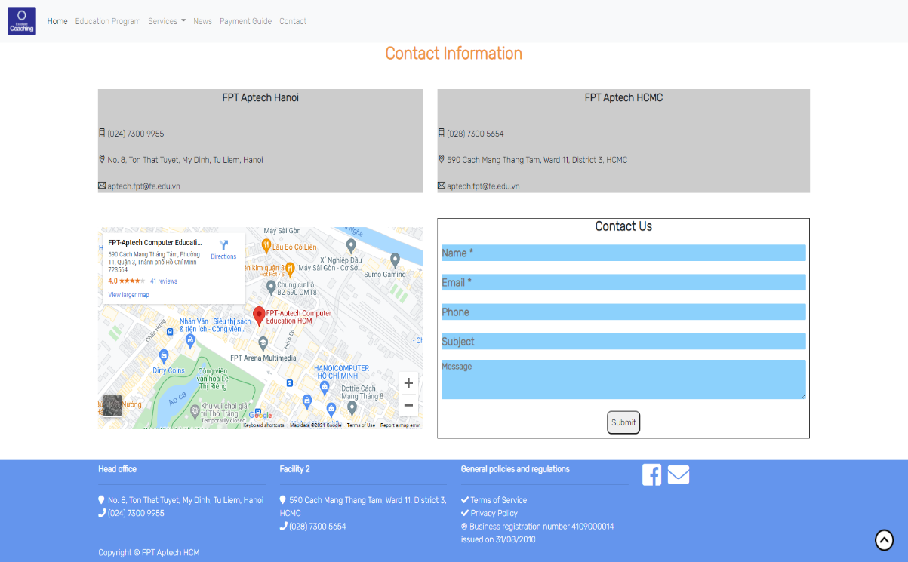

## Footer

## By clicking icon envelope, the new window is created which can connect the center’s email address and subject already.

# **TIME MANAGEMENT**

**STAGE 1 (Jun 11th – Jun 18th)**

* Ideas discussion
* Create layouts for website
* Search for general information for all pages

**STAGE 2 (Jun 18th – Jul 5th)**

* Collect images, details informations
* Build webpages (HTML, CSS, JS)
* Write first project report

**STAGE 3 (Jul 5th – Jun 14th)**

* Edit and complete website
* Test in different browsers and monitor sizes
* Write final project report

# **TASK SHEET 2**

|  |  |  |  |  |  |  |  |
| --- | --- | --- | --- | --- | --- | --- | --- |
| **Project Ref. No.** | | **Project Title** | **Activity Plan Prepared**  **by** | **Date of Preparation of Activity Plan** | | | |
| **Sr. No** | **Task** | **Actual Start Date** | **Actual Days** | **Team**  **mate Names** | **Status** |
| 1 | Design Homepage, structure of website and coding, editing | EXELLENT COACHING | Duy | 11/06/2021 | 14 | Duy | Completed |
| 2 | Design Education Program, Course, and coding, editing  Design logo, color scheme for website | EXELLENT COACHING | Bao | 11/06/2021 | 14 | Bao | Completed |
| 3 | Design Services, News and coding, editing | EXELLENT COACHING | Kiet | 11/06/2021 | 14 | Kiet | Completed |
| 4 | Design Payment method, Contact and coding (include Geolocation API), editing | EXELLENT COACHING | Phat | 11/06/2021 | 14 | Phat | Completed |
| 5 | Write first project report | EXELLENT COACHING | Duy | 22/06/2021 | 2 | Duy, Phat | Completed |
| 6 | Design sign in/ sign out form page and coding, editing | EXELLENT COACHING | Duy, Phat | 03/07/2021 | 5 | Duy, Phat | Completed |
| 7 | Design function add to cart from Education Program and coding, editing | EXELLENT COACHING | Bao, Kiet | 03/07/2021 | 5 | Bao, Kiet | Completed |
| 8 | Group pages together with links and update information | EXELLENT COACHING | Kiet | 03/07/2021 | 10 | Kiet, Duy | Completed |
| 9 | Test website in different browsers | EXELLENT COACHING | Bao, Phat | 07/07/2021 | 5 | Bao, Phat | Completed |
| 10 | Find out bugs and edit some details of website | EXELLENT COACHING | Duy, Kiet | 07/07/2021 | 5 | Duy, Kiet | Completed |
| 11 | Write final project report | EXELLENT COACHING | Duy | 12/07/2021 | 2 | Duy | Completed |

|  |  |
| --- | --- |
| Signature of Faculty | Signature of Leader Team |
|  |  |

# **CHECKLIST VALIDATION**

|  |  |  |
| --- | --- | --- |
| **Task No.** | **Requirement** | **Validation** |
| 1 | The Home Page should have suitable logo, and decent colour combination. | Yes |
| 2 | Information should be neatly placed at suitable location. | Yes |
| 3 | Various pages having information about different courses/subjects taught at the classes, Faculty/Teachers complete information and previous year’s success stories should be listed. | Yes |
| 4 | The site should display a menu which will contain the options for brief introduction about the above mentioned information, location/address of the coaching classes and any other information if required. | Yes |
| 5 | The information should be categorized according to different subjects like if a User wants to see details of ‘Commerce’ then he click on a Link/button/menu etc and he will see details of course structure of commerce. Similarly for ‘Mathematic’, ‘Languages’ and other subjects. | Yes |
| 6 | When a user selects any course stream, complete list of subjects for that course stream will be displayed. | Yes |
| 7 | Details of the courses should be displayed on the Web Page along with the title and it should be stored in Individual Word documents which can be downloaded or viewed by the User who wishes to see the same. | No |
| 8 | Price List for all courses should be available for download. | No |
| 9 | There should be a “Contact Us” page which will have the Address of the Coaching Classes and the mail address which when clicked will invoke the local mail client from where they can send an email. Address of the Company should be displayed using GeoLocation API (eg. GoogleMaps). | Yes |

# **REFERRENCE**

#### Computer Centre of University of Science

[*https://www.csc.edu.vn*](https://www.csc.edu.vn)

#### Excellent Coaching Centre

[*https://www.excellentcoachingdwarka.com*](https://www.excellentcoachingdwarka.com)